SCALING USER’S COMPUTE RESOURCES
A. The need for reactive architectures
Applications need to handle large amounta of data with sub-second response time while having close to 100 percent uptime
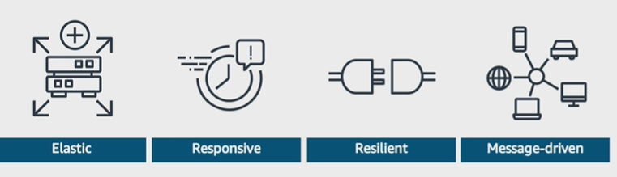
B. Amazon EC2 Auto Scaling
- Manages a logical collection of Amazon Elastic Compute Cloud (Amazon EC2) instances called an Amazon EC2 Auto Scaling group across Availability Zones.
- Launches or retires EC2 instances configured by launch templates
- Resizes based on events from scaling policies, load balancer health check notifications, or chedule actions
- Integrates with Elastic Load Balancing (ELB) to send new instances registrations and receive health notifications.
- Balances the number of instances across Azs
- Is available free of charge

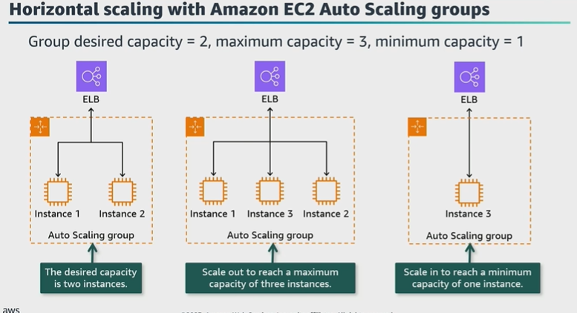
C. Amazon EC2 Auto Scaling mechanisms
- Scheduled actions:
+ Scale based on a date and time
+ Are fro predictable workflows
- Dynamic policies:
+ Scale based on tracked metrics
+ Are for moderately spiky workloads
- Predictive policy:
+ Scales based on previous traffic patterns with machine learning
+ Is for workload traffic that can be predicted with a pattern

